Editing and managing content files

# Overview

The files table in CAMPER allows you to view, manage, and edit all of the content files used in your program. For information on creating file name entries for the files table, see the document “Making a mini-lesson.”

This document shows you how you can use the files table to:

* View the metadata attached to a file
* Distinguish between files that have been imported from CORE JUICE and not modified vs. imported files that have been modified or created specifically for your program.
* Access file authoring templates
* Preview how the file will appear on the site
* Use versioning to manage the file workflow and move files between the Dev, QA, and Production servers
* Delete and rename files

# The files table

1. Click the “files” icon in the table toolbar to access the files table.



1. The files table will load showing all of the files that have been imported into or created for your program.   
     
   The search field above and the search filters to the left of the files table allow you to filter which files are displayed.   
     
   See below for more information about each column of the files table.

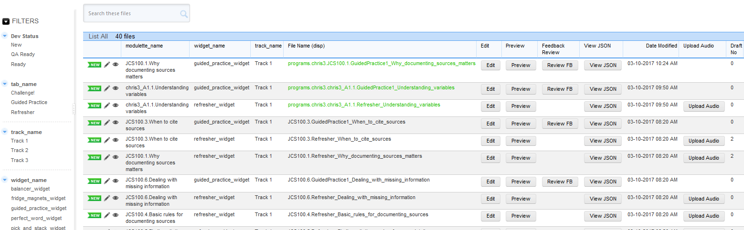

| **column** | **notes** |
| --- | --- |
| modulette_name | This shows which modulette the content file is a part of. |
| Widget_name | This shows what type of widget (content player) will play the file. |
| Track_name | This shows the track the file belongs to. Tracks appear in order on the tab “choose” page. |
| File Name (disp) | This is the name of your file. The “programs/[program id]” text is added to it automatically. |
| Edit | This button will take you to the authoring template for the file. |
| Preview | This button will show how the file will appear on the site. It loads the file from the dev server and will display the file as it exists on Dev. |
| Feedback Review | This button is only available for files that are used in a guided practice. It shows a preview of the guided practice that also displays all of the possible feedback for each question. This allows you to review feedback without having to first select every answer option. |
| View JSON | This displays the underlying json text that is saved by the authoring template. It is very useful for reviewing game text—it is the only view that allows you to see all of the text for a game on the same browser page. |
| Date Modified | This date shows the last time the file’s metadata was modified (Creation date, Dev status, draft NO, etc.) This date will NOT reflect any changes made to the content of the file (the student facing content). |
| Upload Audio | This button will only appear for files that are used for refreshers. It is used to add narration files. |
| Draft No. | You can set the Draft Number of a file to show how far along the file is in the production pipeline. The draft numbering system used by the JUICE production team is as follows:  Draft 1 – Submitted by author and returned  Draft 2 – Ready for internal review  Draft 3 – Ready for copy editing  Draft 4 – Ready for narration/final for the site |
| Dev Status  Copy to QA  Date to QA  Preview QA  QA Status  Copy to PROD  Date to PROD  Preview PROD | This group of statuses and buttons is used for identifying which servers a file currently exists on and to mark a file as ready to be pushed to the next server.  Dev Status shows what stage of the authoring/review process the file is at on the Dev server. QA Status shows this for the QA server.  The default statuses for newly created files will be “New” for Dev Status and blank for QA Status.  You can establish your own workflow rules and definitions. These are the rules established by the JUICE production team:  **New** = File entry is created  **In Progress** = An author is modifying the content of the file, and the file should not be edited or opened by anyone other than that author. This is not enforced by CAMPER.  **Submitted** = Draft has been submitted and is ready for production team review  **Locked** = Production team is working on the file. Edit button is only visible to those with the role “administrator” or “manager.” Authors cannot edit the file.  **Returned** = File has been sent back to the author for revisions  **Ready** = Ready for internal review  **QA Ready** = Ready for release to the QA server and external review  Once a file is marked as QA Ready it can be copied to the QA server.  **Ready** = File is ready for external review  **Returned** = External editor returned the file with comments  **Submitted** = Corrections submitted by author, ready for next review  **Prod Ready** = Ready for production  Note that all edits take place on the dev version of the file, so once a file has been updated and submitted, it must be re-pushed to the QA server.  The Preview PROD and QA buttons function similarly to the other “Preview” button, but load the file from the PROD and QA servers respectively. |

Imported, modified, and new files

You may notice that some files names in the files table look different than others. Some may have a green font and have “programs.[yourprogramid]” added to the beginning of the file name, while others are in black font and begin with the module ID. This is meant to distinguish between files that have been imported from CORE JUICE, and imported files that you have modified or created specifically for your program.

Files are stored in directories in S3 and their file names display in the CAMPER files table. When you import a module from CORE JUICE, the content file names associated with that module are also imported into your program and appear in the files table. Since these are pointing to the original CORE JUICE versions of the files in S3, any updates made to the original file in CORE JUICE will automatically appear in your program.

An imported file will remain in this state until you make a change to its contents. Once a change to the contents of a file is made and saved, the file itself will be copied into your own program’s directory in S3. The file name in CAMPER will be updated with “programs.[yourprogramid]” added to the beginning of the file name and the font will turn green.

NOTE: You need to refresh the files table after making an edit to see the update.

The file name is no longer referencing the original CORE JUICE file’s S3 bucket and is now pointing to your program’s S3 bucket. Updates made to the original file in CORE JUICE will no longer be visible in your program, as there are now two distinct files stored in different S3 directories.

Files that you create for your own program’s custom modules are stored in your own program’s bucket in S3. When you create one of your own files, “programs.[yourprogramid]” is automatically added to the beginning of the name you specify. These file names will be green as well.

Editing a file’s contents

Modifications to a file’s contents are done from the files table. Click the “Edit” button next to the file name that you would like to modify. This will open the authoring template for that file.



See the instructions on authoring refresher, guided practice, and mini-game widget files to learn more about how to use the authoring templates to modify your content files.

IMPORTANT!!! You must clear your cache before editing a file. This will ensure that the most up-to-date version of that file displays.

If you make round of edits to a file and then open that same file again without clearing your cache, you most likely will not see the first round of edits. If you save the file, your previous changes will be overwritten. There are no “are you sure” protections against doing this!

If you edit an imported file and cause its name to change and turn green, you will need to publish the modulette that it belongs to. This will ensure that it displays correctly on the site.

Previewing a file

You can preview how a file will appear on the site by clicking the “Preview” button.



This will show you the file as it currently exists on the dev server. It is useful for viewing changes made in the editor template.

If you edit a file that was imported from CORE JUICE, you won’t be able to view your changes with the preview button until you’ve refreshed the files table page and updated the file name to include the name of your program.   
  
 If you try to preview the file before CAMPER is able to modify the file name, the preview button will bring you to a view of file as it exists on CORE JUICE, and not the version of the file as it exists in your program.

If you want to preview the file as it exists on the QA or Prod server, there are two other preview buttons that will load the file from those servers.

../Instructions%20Screenshots/Files%20table/Screen%20Shot%202017-03-03%20at%2011.53.42%20AM.png

* Click “Prev. QA” to view the version of the file that is on the QA server.
* Click “Prev. PROD” to view the version of the file that is on the PROD server (and the live site).

Managing file workflow

A new file is saved to the JUICE dev server automatically. For the file to be accessed from the QA or production servers, it must be published to those servers.

Files can only be published to the QA server when their Dev status is “QA Ready.” Publishing to QA makes a copy of the file from dev and pushes it to the QA server.

Files can only be pushed to the Prod server when the QA status is “Prod Ready.” Publishing to production makes a copy of the file from the QA server and pushes it to the prod server.

Copies can never be copied directly from Dev to QA.

You can use a combination of the file draft number and statuses to manage the workflow of your files. See the table above for the workflow used by the JUICE production team.

Editing file workflow metadata

1. To edit the metadata (Draft No, Dev status, QA status, etc) of an individual file, click the pencil icon in the row of the file you wish to edit.

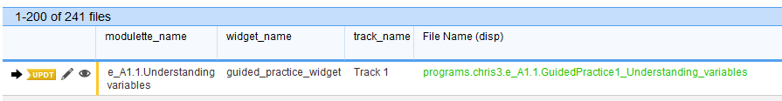

1. This will load the edit file form for the file.

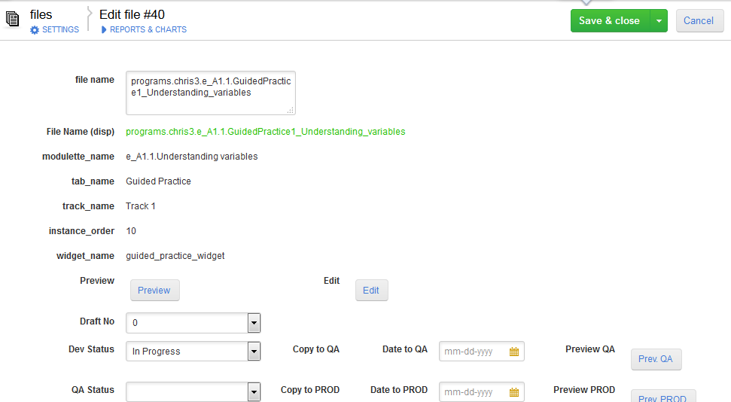

1. From this form, you can:
   * Preview and edit the content of the file
   * Change the Draft No.
   * Set the Dev Status
   * Set the QA status
   * Copy the file to QA (if the Dev Status is set to QA Ready)
   * Copy the file to Prod (if the QA Status is set to PROD Ready)
   * Preview the file from the QA or PROD servers
   * Upload Audio for Refreshers
2. To change the draft number, Dev status, or QA status, click the field’s dropdown menu and select the number/status that is appropriate for the file’s position in the development pipeline. Refer to the table above for definitions of draft numbers and statuses.
3. Setting a file’s Dev status to “QA Ready” will cause a “Copy to QA” button to appear on the form. Setting the QA Status to “PROD Ready” will cause a “Copy to PROD” button to appear on the form.

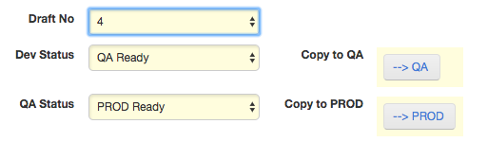

These buttons will allow you to copy the file to the next server in the production pipeline, culminating in the final, student-facing, production server.

Editing file workflow metadata with grid edit

You can also edit a file’s metadata using the Grid Edit function. This is useful if you want to edit the data of multiple files—allowing for batching editing of Draft NO, Dev Status, and QA status.

1. Click the “Grid Edit” icon located above the table.

../Instructions%20Screenshots/Files%20table/Screen%20Shot%202017-03-03%20at%2012.49.51%20PM.png

1. This will load a form that looks similar to the files table, but contains editable cells.

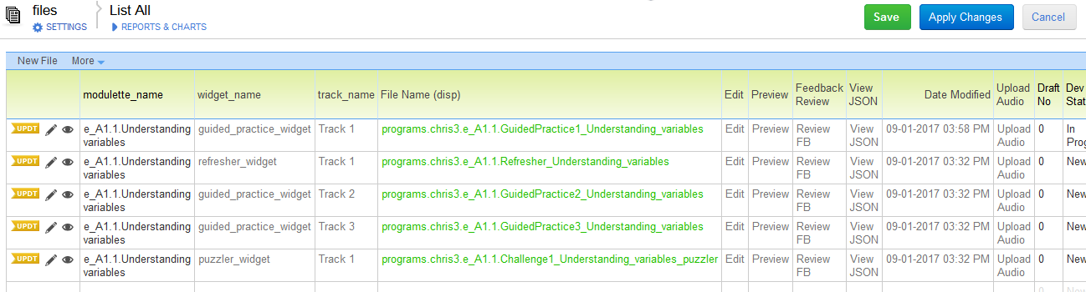

1. Double click the field/cell you would like to edit and the cell will turn into a dropdown menu.

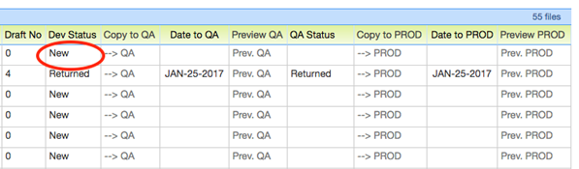

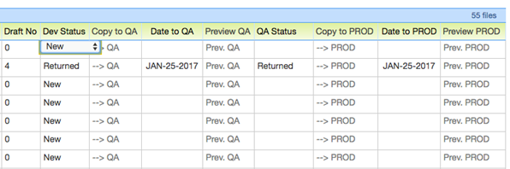

1. Select an option from the dropdown menu that appears

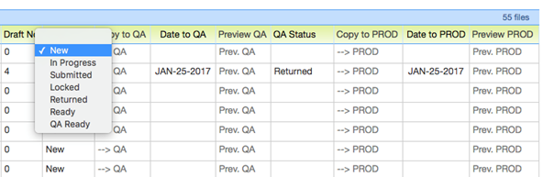

1. Repeat steps 3 and 4 for all of the files/fields that you wish to edit. Fields that you have modified will be highlighted in yellow.

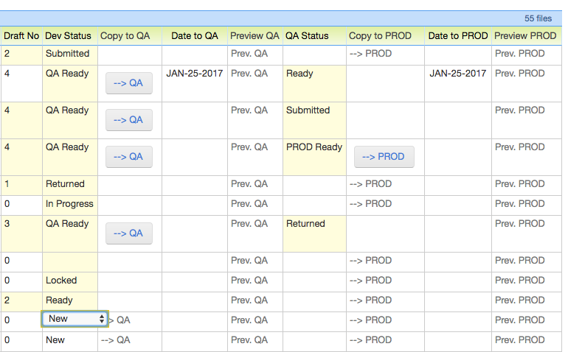

1. When you are done, click either the “Save” button or the “Apply Changes button above the table.

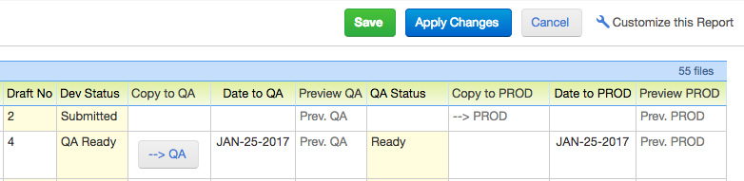

Clicking “Save” will return you to the files table. “Apply Changes” will save what you have done but return you to the grid edit view to continue editing. This is useful if you are making a lot of changes and want to save your progress mid-way through to avoid losing them and having to start over.

Editing file names and copying files

This functionality is only supported for CORE JUICE administrators. If you need a file name changed or a file copied, please contact the Core JUICE team.

Deleting files

Deleting files will cause “orphan” data in your program, and should be done by a program manager.

1. To delete a file, click on its pencil icon in the files table to load the edit view.
2. The edit form will load. Click the delete icon at the top of the form (near the save button).

../Screen%20Shot%202017-03-03%20at%201.34.14%20PM.png

1. This will delete your file, but it won’t remove all trace of it from the site. The widget instance and track that it was used in will still exist and be available for students to see in the site. But nothing will load if they try to click these links.

You must delete the module_instance and the track to finish the deletion process.

1. Navigate to the widget_instances table and use the search bar to look up the modulette ID containing the widget_instance you need to delete. Click the edit icon for that widget_instance.

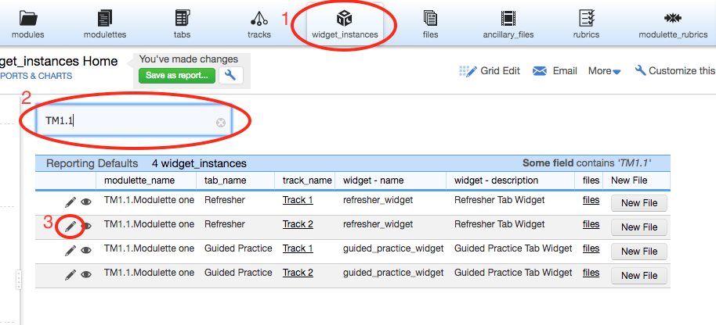

1. The edit form for the widget_instance will load. Click the delete icon at the top of the form.

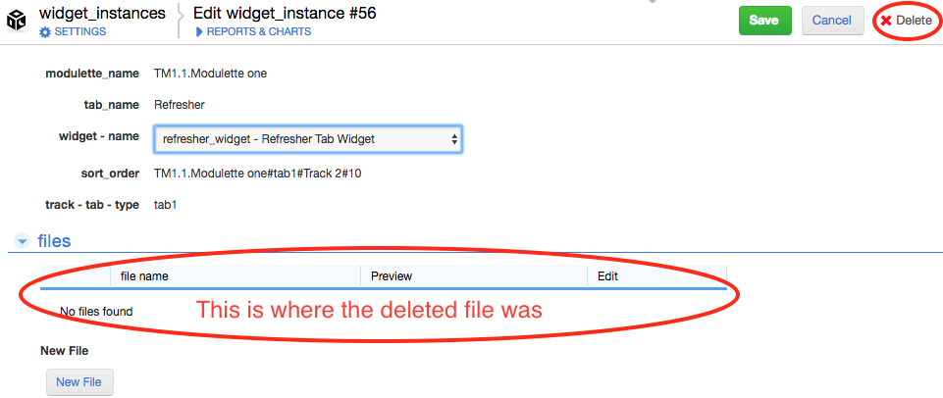

1. Confirm that you want to delete the widget_instance and you will be brought to the widget_instance table. Now you need to delete the track that contained the deleted widget_instance and file.
2. Navigate to the tracks table and use the search bar to look up the modulette ID containing the track you need to delete. Click the edit icon for that track.

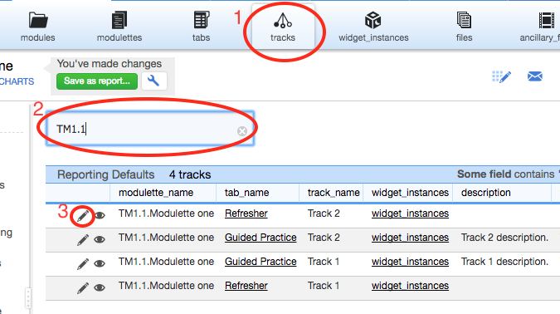

1. The edit form for the track will load. Click the delete icon at the top of the form.

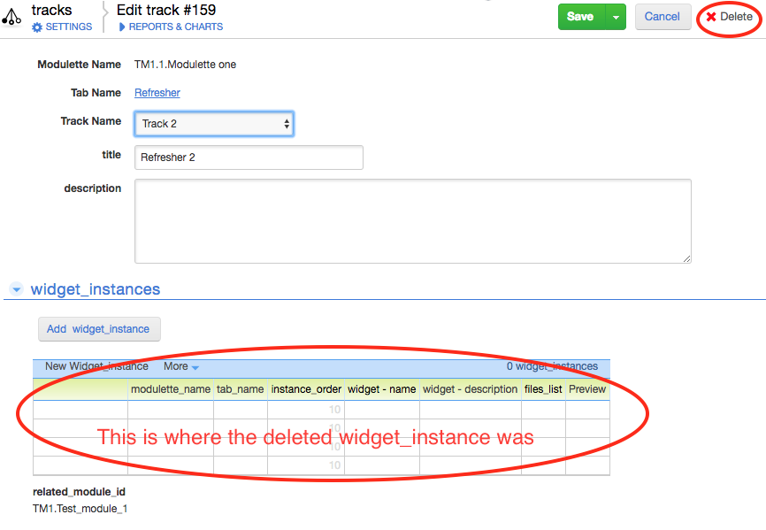

1. Once the track is deleted, you need to publish the modulette and the module that contained the deleted items. This will remove all traces of the deleted file from the site.